ENDPOINT SECURITY BASELINE GUIDE
For a Real Estate Agency
Windows Event Viewer – Practical Monitoring Prototype

Assigned Role | Member 3 – Individual Contributor
Primary Tool | Windows Event Viewer
Project Type | Endpoint Security Monitoring Baseline
Environment | Windows endpoint / safe lab environment
Evidence Provided | Event Viewer screenshots for Event IDs 4625, 4624, 4648, 4672 and 1102
Prepared as an internship project deliverable

1. Executive Summary
This contribution demonstrates a practical endpoint-security monitoring baseline using Windows Event Viewer. The purpose is to identify security-relevant Windows events, define detection criteria, and document an appropriate initial response for a real estate agency environment. The supplied evidence contains filtered Security log views for Event IDs 4625, 4624, 4648 and 4672.
The screenshots show that the test endpoint is generating these event types. The presence of an event is not, by itself, proof of compromise; the events should be correlated with the user, time, source, process and business context before an incident is declared.

2. Objective
- Use Windows Event Viewer to review endpoint security logs.
- Define at least five practical detection/alert rules.
- Create a sample log-review report that a security team could use as a baseline.
- Document response steps for each alert type.
- Provide screenshots as evidence of the monitoring work.

3. Scope
- Primary log sources: Windows Security and System logs.
- Focus: authentication activity, credential use, privileged logons and log tampering.
- This is a prototype/baseline and is not intended to replace a SIEM or production incident-response platform.
- Testing should be performed only on an authorized lab or company-owned endpoint.

4. Detection and Alert Rules
The following rules are designed as baseline monitoring logic. Event IDs are used as filters in Event Viewer. For a production deployment, thresholds, allow-lists and correlation logic should be added.

Detection Rule 1: Failed Login Attempts
Event ID | 4625
Log | Windows Logs → Security
Meaning | An account failed to log on.
Risk | Medium to High depending on frequency and context.
Detection / Monitoring Logic | Monitor repeated 4625 events for the same account, source or endpoint within a short time window.
Response | Verify the username and source information. Check whether the attempts are expected. Repeated or suspicious attempts should be investigated for password guessing or brute-force behavior.

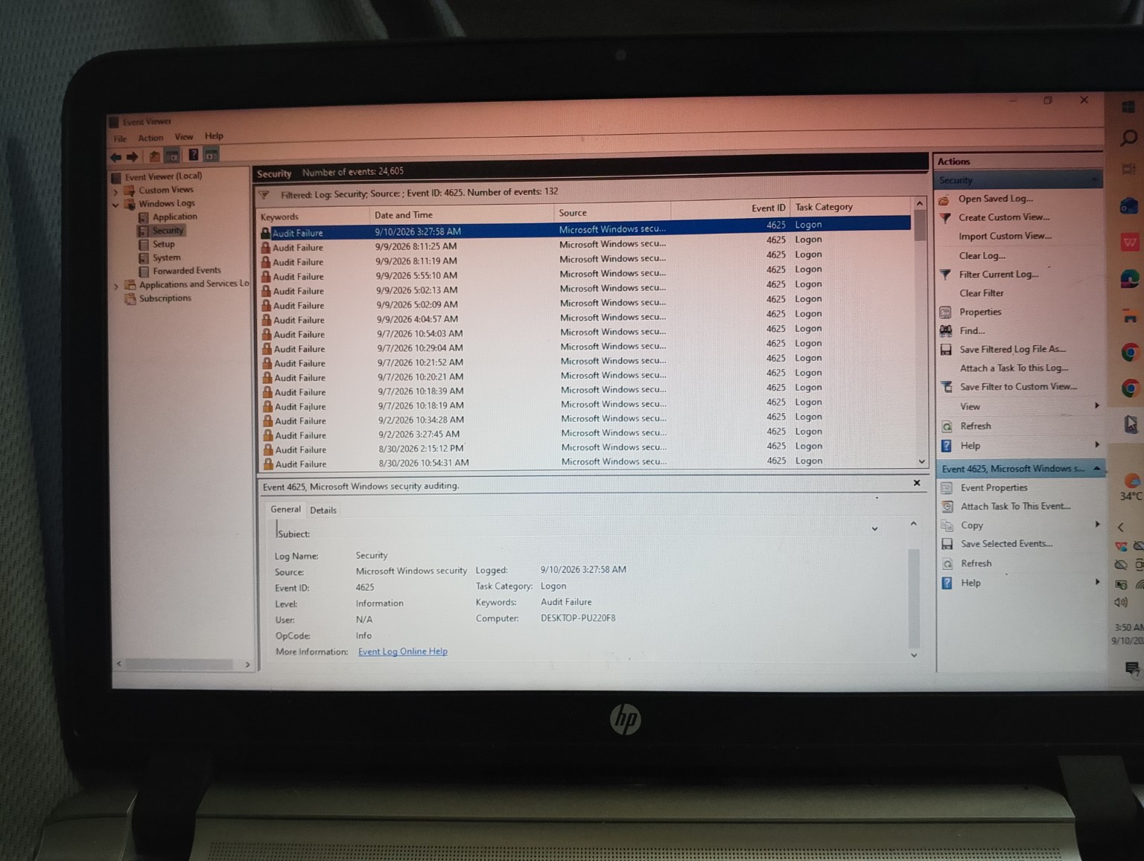
Figure 1. Supplied Event Viewer evidence filtered for Event ID 4625 (132 events shown in the filter).

Detection Rule 2: Successful Logon
Event ID | 4624
Log | Windows Logs → Security
Meaning | A successful account logon was recorded.
Risk | Medium; higher when the time, user or source is unusual.
Detection / Monitoring Logic | Review successful logons for unusual accounts, unusual times, unexpected logon types or other anomalies.
Response | Verify the user and timing. If the login is not expected, review related events, account activity and source information.

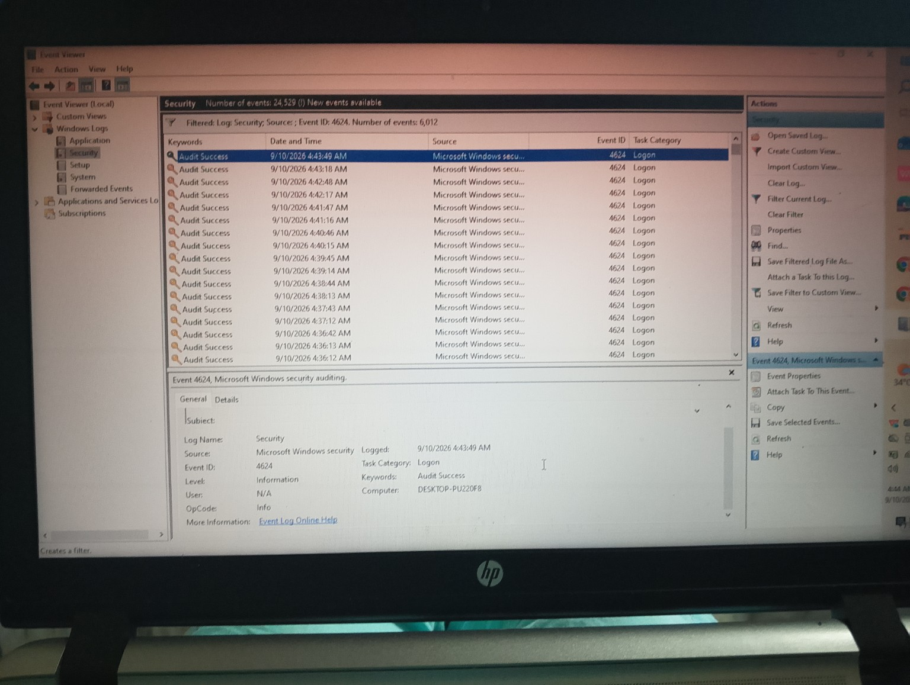
Figure 2. Supplied Event Viewer evidence filtered for Event ID 4624 (6,012 events shown in the filter).

Detection Rule 3: Explicit Credential Usage
Event ID | 4648
Log | Windows Logs → Security
Meaning | A process attempted to use explicitly supplied credentials.
Risk | Medium to High depending on the process, account and target.
Detection / Monitoring Logic | Investigate unexpected 4648 events, especially when the account, process or target resource is unusual.
Response | Identify the account, process and target involved. Confirm whether the activity is legitimate. If unexplained, investigate the process and related authentication events.

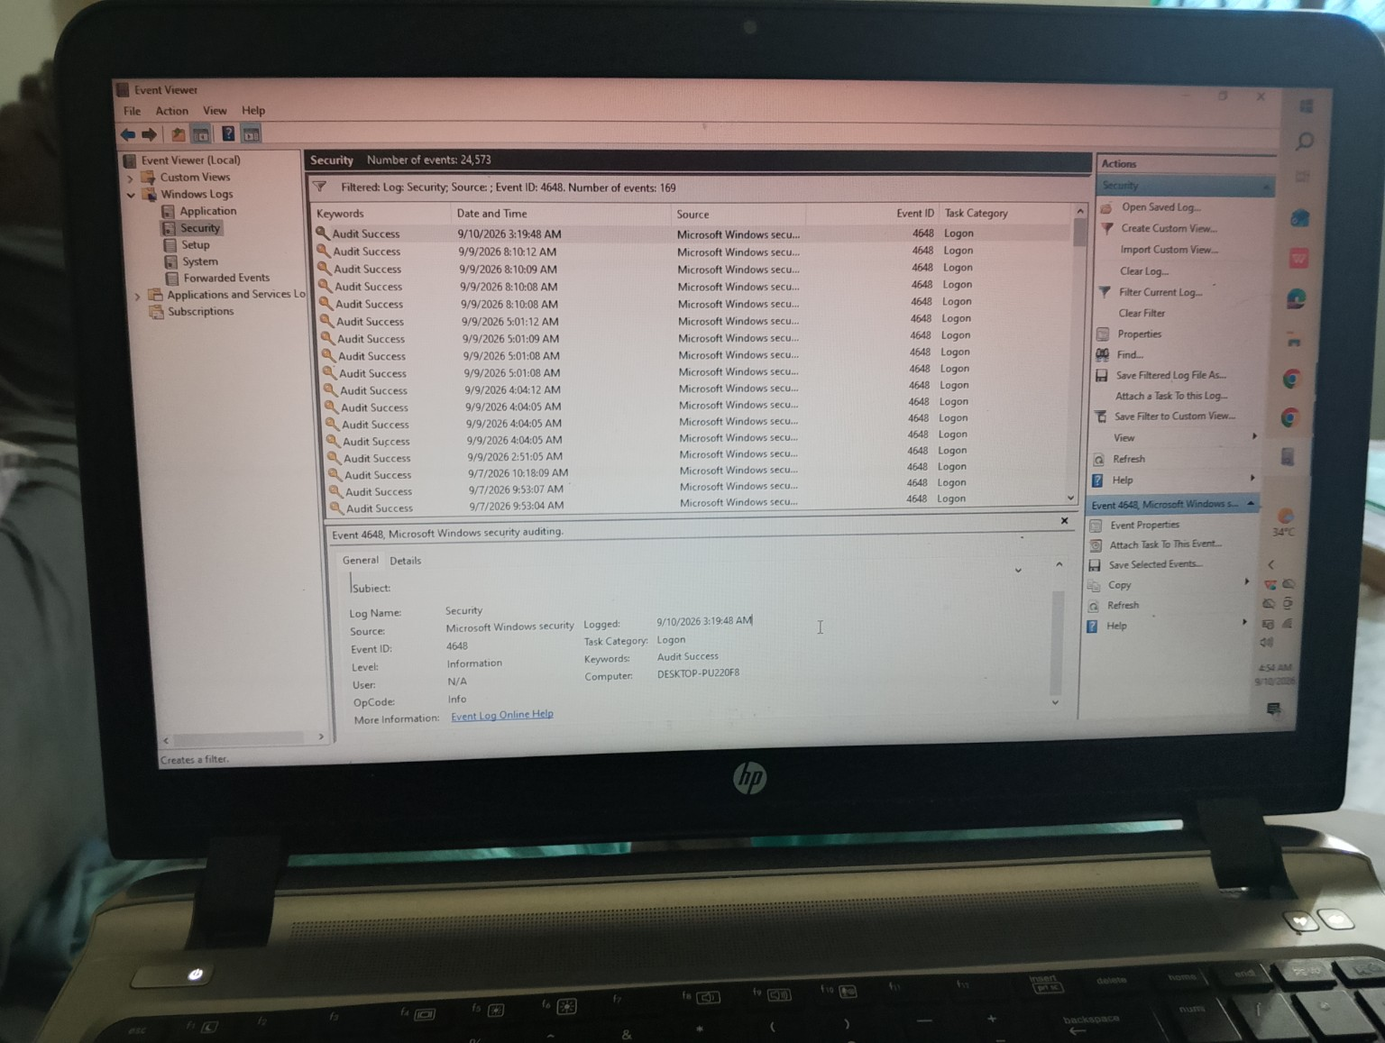
Figure 3. Supplied Event Viewer evidence filtered for Event ID 4648 (169 events shown in the filter).

Detection Rule 4: Special Privileges Assigned to a New Logon
Event ID | 4672
Log | Windows Logs → Security
Meaning | Special privileges were assigned to a new logon.
Risk | Medium to High; important when associated with an unexpected account.
Detection / Monitoring Logic | Monitor privileged logons and determine whether the account should legitimately receive special privileges.
Response | Verify the account and reason for privileged access. Correlate with Event ID 4624 and other administrative activity. Escalate unexpected privileged access for investigation.

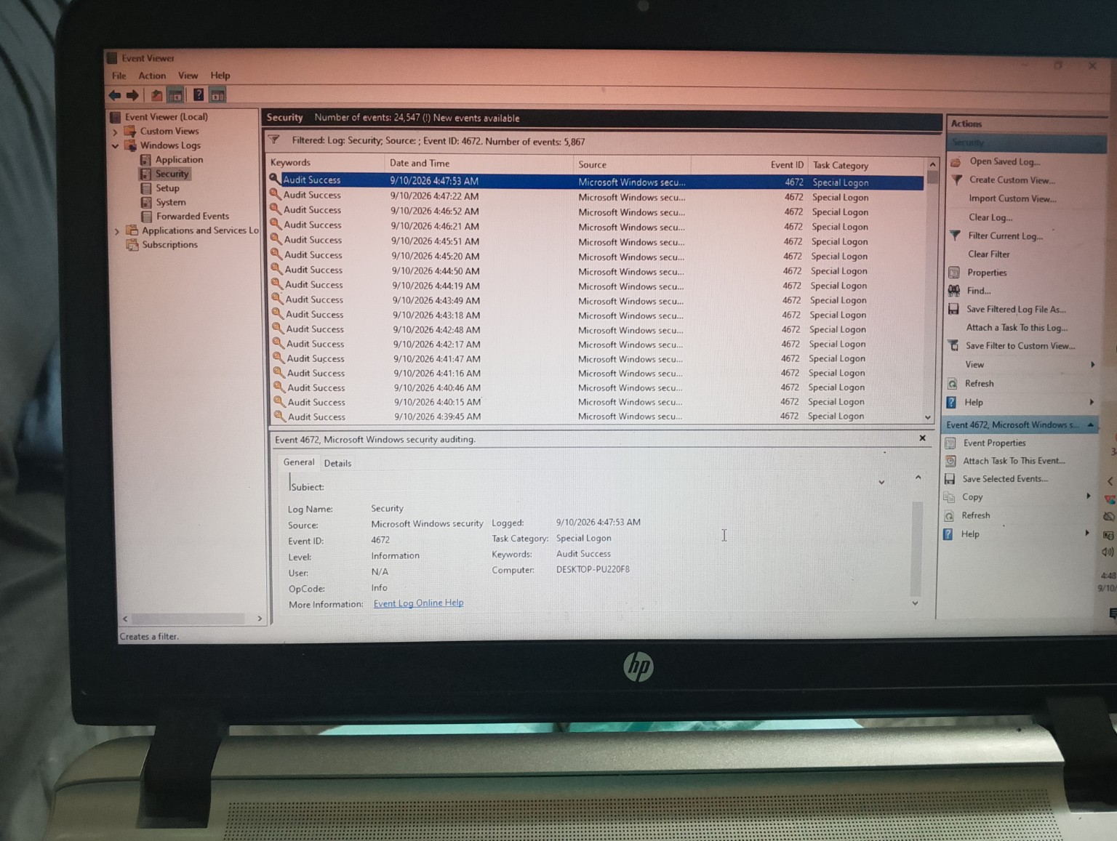
Figure 4. Supplied Event Viewer evidence filtered for Event ID 4672 (5,867 events shown in the filter).

Detection Rule 5: Security Audit Log Cleared
Event ID | 1102
Log | Windows Logs → Security
Meaning | The Windows Security audit log was cleared.
Risk | High/Critical when unexpected.
Detection / Monitoring Logic | Alert whenever Event ID 1102 occurs outside an approved administrative maintenance procedure.
Response | Record the time and account. Investigate activity immediately before the log was cleared, correlate with other available logs, preserve evidence and escalate as a potential log-tampering event.

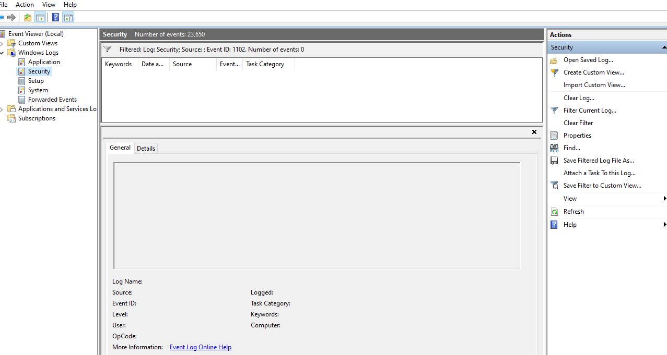
Figure 5. Event Viewer evidence filtered for Event ID 1102 (0 events found — no security-log clearing detected on this endpoint).
Evidence status: Screenshot provided (Figure 5). The Security log was filtered for Event ID 1102 and returned 0 events, confirming that no audit-log clearing occurred on this endpoint. This rule remains a recommended baseline detection.

5. Sample Log-Review Report
The following summary converts the observed Event Viewer filters into a concise security-review format. The event counts are the counts visible in the supplied screenshots at the time of capture.
Event ID | Detection | Observed Filter Count | Risk | Initial Action
4625 | Failed logon | 132 | Medium–High | Investigate repeated failures
4624 | Successful logon | 6,012 | Medium | Verify user/time/source
4648 | Explicit credentials | 169 | Medium–High | Investigate account/process/target
4672 | Special privileges | 5,867 | Medium–High | Review privileged access
1102 | Security log cleared | 0 | High/Critical | Investigate possible tampering

6. Recommended Review Workflow
- Filter the relevant Windows log by Event ID.
- Review timestamp, account, source/computer and other available event details.
- Determine whether the activity is expected business activity.
- Correlate related events (for example, 4625/4624 authentication activity with 4672 privileged logons).
- Escalate unexplained high-risk activity and preserve relevant evidence.
- Document the finding, action taken and final disposition.

7. Response Matrix
Alert | Immediate Response | Follow-up
4625 – Failed logon | Verify account/source and check repetition. | Investigate password guessing; reset credentials if compromise is suspected.
4624 – Successful logon | Verify user and timing. | Correlate with source, logon type and surrounding activity.
4648 – Explicit credentials | Identify account, process and target. | Confirm legitimacy; investigate unexplained credential use.
4672 – Special privileges | Verify privileged account and purpose. | Correlate with 4624 and administrative actions.
1102 – Log cleared | Treat unexpected occurrence as high priority. | Investigate possible log tampering and preserve other evidence.

8. Implementation and Testing Notes
- Windows Event Viewer was used to access Windows Logs → Security.
- The Event Viewer filter was used to isolate individual Event IDs.
- The supplied screenshots demonstrate filtered results for 4625, 4624, 4648 and 4672.
- Event 1102 is included as an additional baseline rule; the supplied screenshot shows 0 matching events, confirming no security-log clearing on this endpoint.
- The captured events should be treated as lab evidence and reviewed in context; normal Windows activity can generate many security events.
- No production or third-party system should be tested without explicit authorization.

9. Evidence Summary
Evidence | Purpose | Status
Event ID 4625 screenshot | Failed logon monitoring | Provided
Event ID 4624 screenshot | Successful logon monitoring | Provided
Event ID 4648 screenshot | Explicit credential monitoring | Provided
Event ID 4672 screenshot | Privileged logon monitoring | Provided
Event ID 1102 rule | Security log tampering detection | Provided (0 events — no tampering detected)

10. Conclusion
This prototype establishes a practical Windows endpoint monitoring baseline for a real estate agency. It covers authentication failures and successes, explicit credential use, privileged logons and security-log tampering. The approach can later be extended with additional Event IDs, thresholds, centralized log collection and SIEM correlation rules.

11. Suggested Screen-Recording Demonstration
For the mandatory 5–10 minute video, demonstrate the Windows Event Viewer, show the Security log filters for the captured Event IDs, briefly explain what each event means, then open this report and explain the detection and response table in your own words.
Note: Event counts and timestamps in this report are transcribed from the screenshots supplied for this assignment. They represent what was visible on the test endpoint and should not be interpreted as confirmed security incidents.

